Clifford Forrester, Kathleen Fox, Mashundra Maclin, Courtney Smith, and Joyce Woznica

TEam 73  
Homework #2

Recruiting Advertising Strategy

Contents

Introduction 3

#1 – Campaign Effectiveness 3

#2 – United States Campaign 5

A – Geographic Region 5

B - Keywords 6

C - Day of Week and Hours of Dat 6

Day of the Week 6

Hour of Day 7

#3 – Campaign Costs 9

A – By Region 9

#4 – Performance Measurements 10

#6 – Factors and Considerations 11

List of Figures

Figure 1: Syracuse University Marketing Campaign Performance 3

Figure 2: Syracuse University Marketing Campaign Performance - Normalized 4

Figure 3: Campaign Performance by State ranked by Sessions 5

Figure 4: Campaign Performance by State – Normalized – ranked by Sessions 5

Figure 5: Percent of Sessions by Day of the Week 6

Figure 6: Day of the Week – Metrics Index 7

Figure 7: Budget Allocation for each Day of the Week 7

Figure 8: Percent of Sessions by Hour-of-Day 8

Figure 9: Hour of Day Metrics 9

Figure 10: State Budget Allocation – Accounting 80% of Total Session 10

# Introduction

In this exercise, we will be using Google Analytics to examine the Whitman Graduate Programs Internet marketing campaigns. We will be analyzing data to identify patterns and opportunities. Our goals are to recruit the best United States students, measured by GMAT scores. However, for these campaigns, we are limited to a budget of only $100,000. This must cover all of our advertising costs, but not the Whitman administration costs.

To do this analysis, we will be executing the following:

* Campaign Effectiveness (Question #1)
* United States Campaign (Question #2)
* Campaign Costs (Question #3)
* Performance Measurements (Question #4)
* Factors and Considerations (Question #5)

# #1 – Campaign Effectiveness

What were the time frames for each marketing campaign?

How much was spent on each campaign?

What was the effectiveness of previous campaigns?

1. whitman.syr.edu
2. MBA Marketing – Full-time
3. MBA Marketing – iMBA
4. Delta

The table shown in Figure 1 outlines the following for each campaign:

* Start and end dates
* Total amount spent
* Various performance metrics.



Figure 1: Syracuse University Marketing Campaign Performance

The table shown in Figure 2 normal shows normalized performance relative to total performance.



Figure 2: Syracuse University Marketing Campaign Performance - Normalized

As reflected in these tables:

* The *whitman.syr.edu* campaign
  + Start Date: 2/27/11
  + End Date: 8/23/11
  + Total Spent over timeframe: $37.7K
* The *MBA Marketing – iMBA* campaign
  + Start Date: 2/02/12
  + End Date: 10/26/12
  + Total Spent over timeframe: $80.7K
* The *MBA Marketing – Full-time* campaign
  + Start Date: 10/26/12
  + End Date: 7/01/13
  + Total Spent over timeframe: $71.3K
* The Delta campaign
  + Start Date: 10/1/13
  + End Date: 10/31/13
  + Total Spent over timeframe: $10K

Overall, the *whitman.syr.edu* campaign was the best performing campaign. As shown in Figure 2 with the normalized data, the average daily cost was 25% lower when compared to aggregate performance, with average daily clicks 118% higher at a more efficient average Cost Per Click (CPC) (61% lower). Further, users visited more pages in each session (+22%), which helped increase the average session duration (+30%).

# #2 – United States Campaign

Identify the key aspects of a United States campaign for next year

## A – Geographic Region

1. In which geographic region would you advertise? Which states? Why?

When we researched in which states to advertise for next year’s campaign, we considered both traffic volume and site behavior. We approached our research by investigating those states which accounted for 80% of all sessions and elected to focus on these areas. However, we identified one particular state, Illinois, that potentially would not be a viable state for campaigning because of an over-indexes on bounce rate (+21%), and under-indexes on pages per session and session duration (-14% and -25%, respectively). However, we still generate more non-bounce traffic than if we were to advertise in two or three smaller states due to Illinois’ traffic volume.



Figure 3: Campaign Performance by State ranked by Sessions



Figure 4: Campaign Performance by State – Normalized – ranked by Sessions

## B - Keywords

1. *What key words would you use? Why?*

Mashundra and Kathi to add answer geography here.

Keywords/days and hours – Cliff to respond and compare with Joyce’s hours/days

## C - Day of Week and Hours of Dat

1. *Which days of the week and what time of day would you advertise? Why?*

### Day of the Week

COURTNEY ADDED HER DAY-OF-WEEK FOR COMPARISON – FEEL FREE TO DELETE

The chart below illustrates the % of sessions by day of week. Saturday – Tuesday are our highest traffic days, and begins to trend down beginning Wednesday. Friday is our lowest traffic day, representing 10% of total traffic.

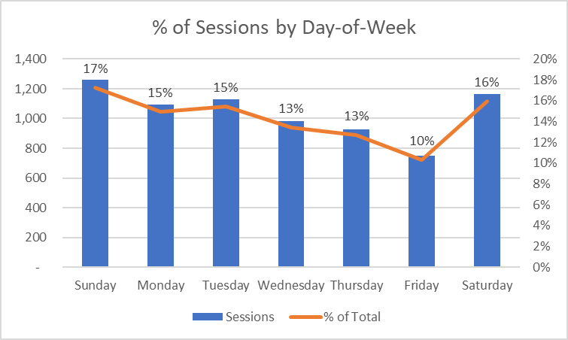

Figure 5: Percent of Sessions by Day of the Week

While bounce rate, pages per session, and average session duration fluctuate slightly day-to-day, no one day deviates more than 10% from the weekly average for each KPI. Based on this, we would not recommend turning off campaigns since no day severely underperforms relative to other days of the week.



Figure 6: Day of the Week – Metrics Index

** Joyce added ** Despite the fact certain days of the week did not provide significant traffic, we felt it was important to keep the campaign available on all days of the week in case trends changed.

Based on the distribution of sessions by day of week, we would allocate the following amounts for each day. Since a day-of-week budget cannot be applied in Google Ads, we would utilize automated rules as a workaround. Automated rules will enable us to create rules to increase or decrease a budget based on a condition, such as day of week.



Figure 7: Budget Allocation for each Day of the Week

### Hour of Day

In reviewing the hours when the campaigns had the most sessions, you can see that a significant jump was made after work hours from Hours 5PM – 12AM EST. In fact, this represents 77% of total sessions in a given day as reflected in Figure 8.

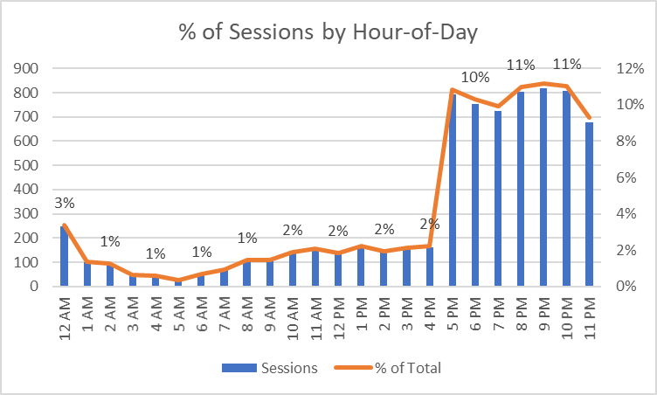

Figure 8: Percent of Sessions by Hour-of-Day

The table shown in Figure 7 compares the normalized values for bounce rate, pages per session, and average session duration across hours. The 4AM hour underperforms across all metrics based on a +/-10% threshold relative to the daily average. (+11% bounce rate, -23% fewer pages per session, -16% lower session duration), thus would set a -100% bid multiplier for hour. Additionally, the 12PM – 1PM hours have some of the lowest session durations relative to other hours (~31% - 36% lower), coupled with a 4%-7% higher bounce rate and 3%-9% lower pages per session, thus would be hours I would also set negative bid multipliers.



Figure 9: Hour of Day Metrics

# #3 – Campaign Costs

Identify the costs for your advertising campaigns

## A – By Region

1. By region

Based on the states previously selected where it would make the most sense to advertise (see section A – Geographic Region beginning on page 5), we calculated the average daily budget for each region. As these states represent approximately 80% of total sessions, we normalized the representation and multiplied the average daily budget ($1,918) by this ratio to determine a state-level budget. For example, New York represents 44.8% of total sessions. To normalize this percentage, we divided 44.8% by 80.7% to get the percent it represents based on this subset (55.5%). We then multiplied 55.5% by $1,918 to get an average daily budget of $1,065.



Figure 10: State Budget Allocation – Accounting 80% of Total Session

1. By degree program

Courtney to provide answer here.

# #4 – Performance Measurements

How would you measure performance of your decisions after implementation?

As we reviewed the previous campaigns and determined that the we would use the *whitman.syr.edu* campaign “Whitman FT MBA” campaign as a baseline for our performance measurement. We selected this campaign because we felt it was the best performing campaign (see section #1 – Campaign Effectiveness beginning on page 3). Using this as a baseline, we determined the following performance metrics:

* Maintain an average cost per click (CPC) of less than $4.03
* Maintain a bounce rate of less than 78.41%
* Increase the average pages per session to more than 1.84
* Increase the average time per session to more than 45 seconds. This is one area where the previous campaign did not perform as well as we would have liked.
* Maintaining or increase sessions over 7,300

Ideally, we would like to perform at a higher rate than previous campaigns, but without conversion rate information, it is more difficult to come up with realistic success metrics for the new campaign. This is why we elected to use a previous campaign as a benchmark to meet or exceed.

Please see the section entitled #6 – Factors and Considerations beginning on page 4 for additional factors and considerations that would help us review our campaign performance. If we could set a desired conversion rate, we could use this information in our performance metric as well.

# #6 – Factors and Considerations

What other factors or considerations are important?

Additional performance signals that are important to consider include impressions, click-through rate, conversions/goal completions, cost per conversion/goal completion, and hourly cost for campaigns.

By having impression data, we can calculate click-through rate to get a sense of relevance for our keyword/ad combinations – for example, if particular keyword/ad combinations resulted in a very low click-through rate, we might adjust our strategy to exclude that keyword as it doesn’t appear to be relevant, or A/B test ad copy to improve click-through rate.

Additionally, by setting up conversion/goal completion tracking, we could better analyze the efficacy of our efforts. While session duration, pages per session, and bounce rate are adequate measures of performance, having conversion/goal completions would allow us to see a more complete picture. Without having this data, we don’t know if someone who came in on a high CPC keyword and had a short session duration ultimately didn’t find value in the Whitman site, or quickly found what they needed and submitted a request for additional information. Further, we could better efficiency by calculating the cost per conversion. This will allow us to better allocate marketing funds to the most efficient areas.

Lastly, hourly campaign data is null in Google Analytics. It would be helpful to either have this available in GA, or have read-only access to Google Ads to view this data. It would make it possible to calculate hourly bid multipliers based on historical CPCs, traffic, and conversion data.

What other data would help in developing an Internet advertising strategy, if you could collect it?

We determined that there were many factors and considerations that would be pertinent to a successful campaign. The first of these was the GMAT score. We have been asked to create a successful campaign for United States students with the highest GMAT scores. However, we have not information about GMAT scores in the previous campaigns run in the past. If we want to truly see the details of how our campaign helped us to recruit those with the highest scores, it would be important to gather the GMAT scores from those that go to our site via the Google Ad campaign.

Another item we felt might help the campaign is to open up or run an additional campaign for those without the highest GMAT scores. There are many successful college students that are over 30 years of age that are going back to college to increase their skill sets to be more competitive. By running a campaign without the concern of GMAT scores for those that may have taken the GMAT quite some ago or not at all could increase university enrollment in the MBA program significantly. This is apparent by the information gathered around keywords and other campaigns specific to online or distance learning.

.